Assignment – 7
1. Create a tabular report for the Leads object.
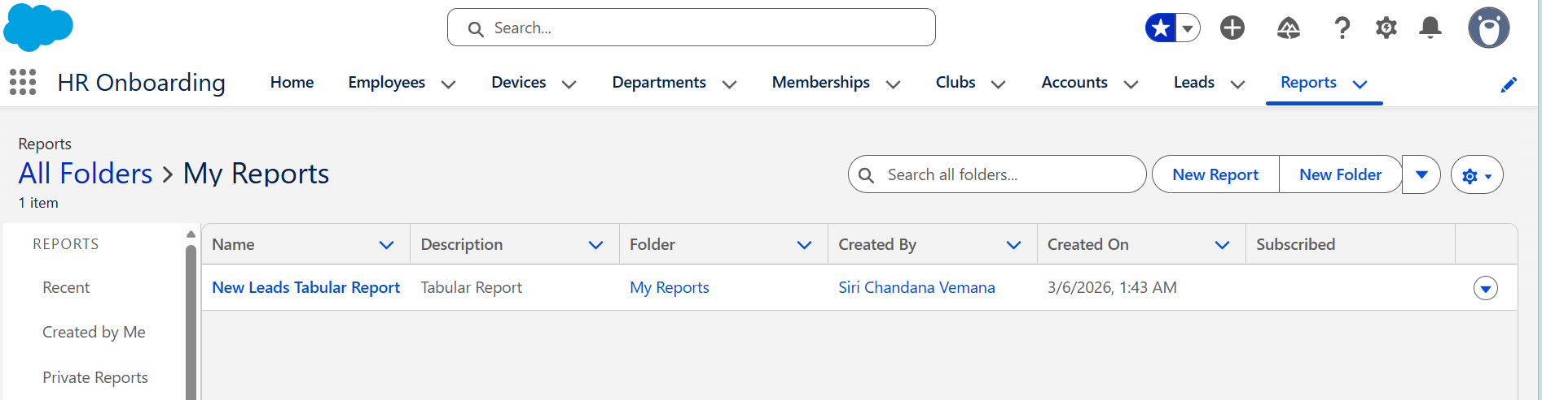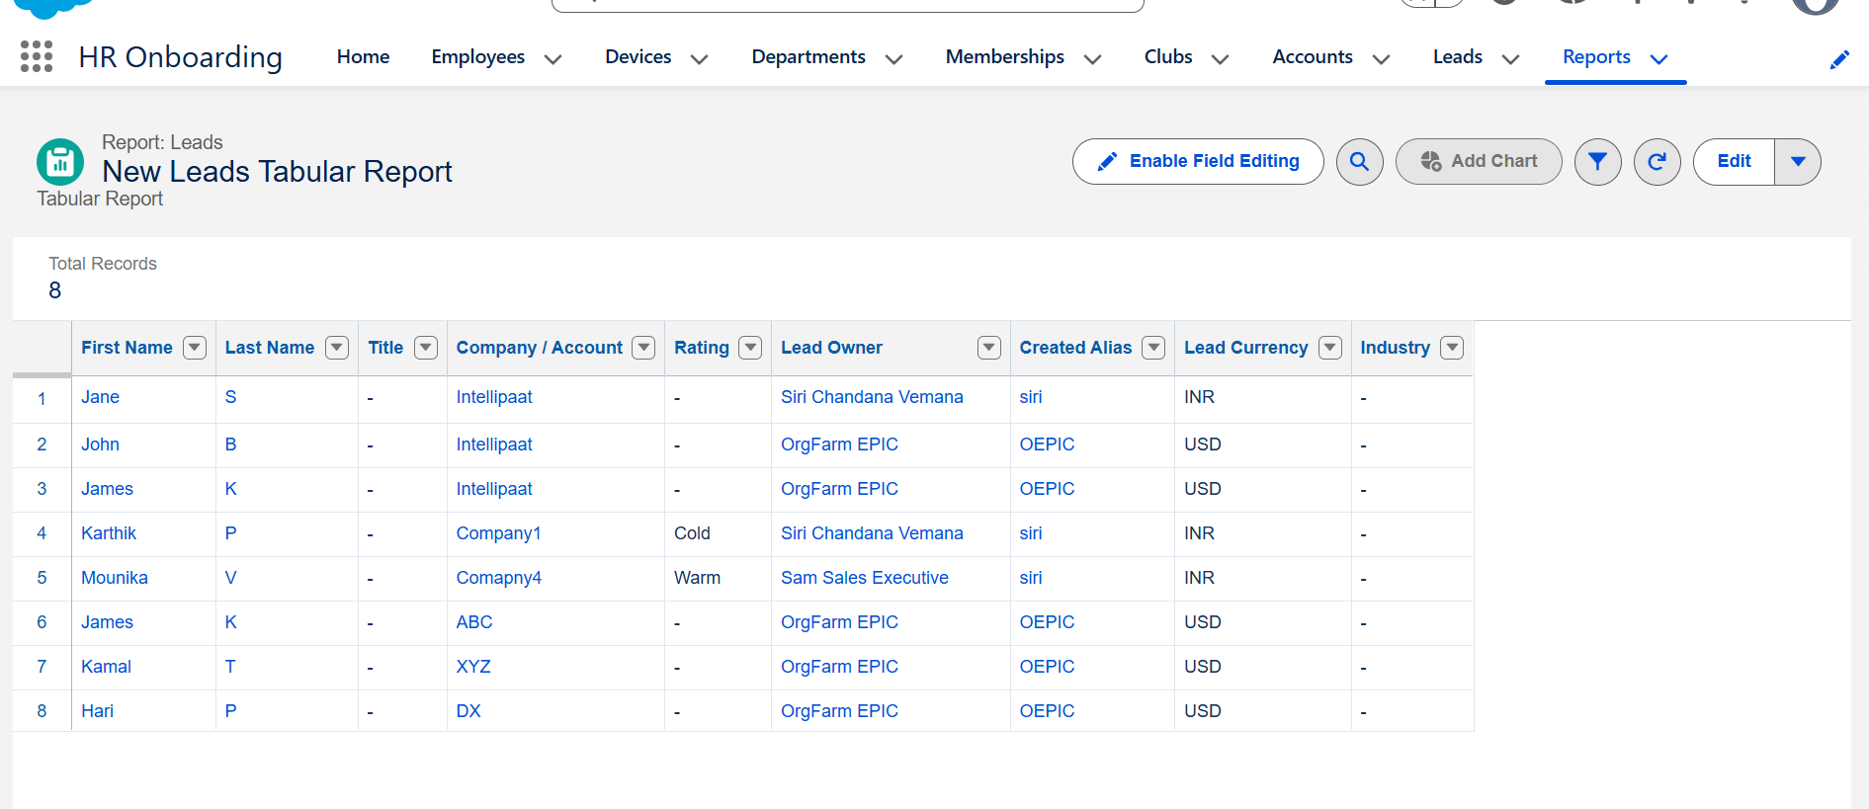

2. Create a summary report for the Opportunity object using the average function.
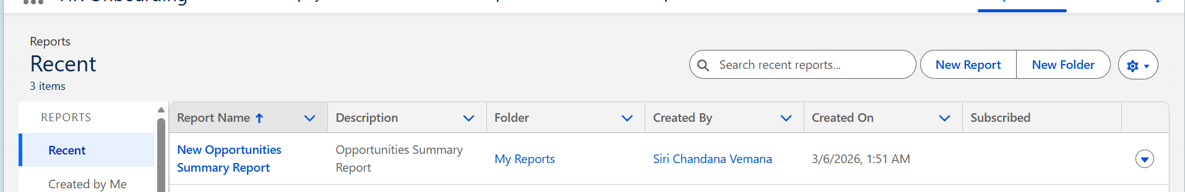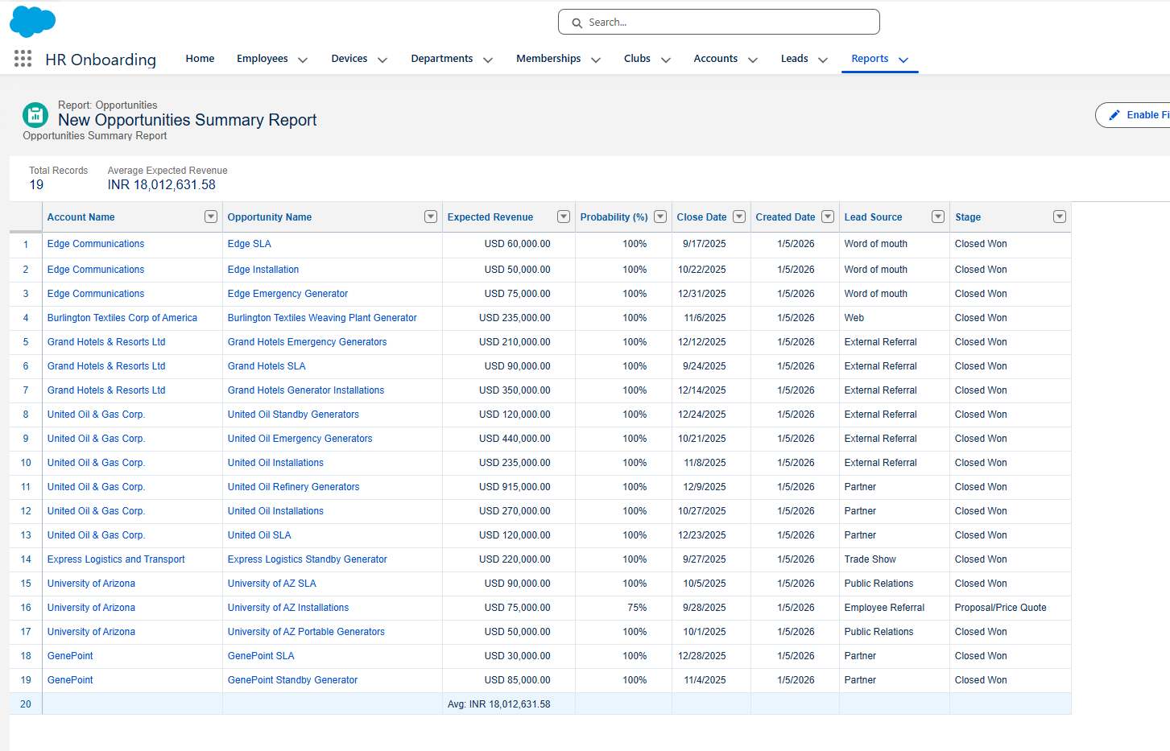

3. Create a matrix report for the Opportunity object with dimensions as Stage and Amount.
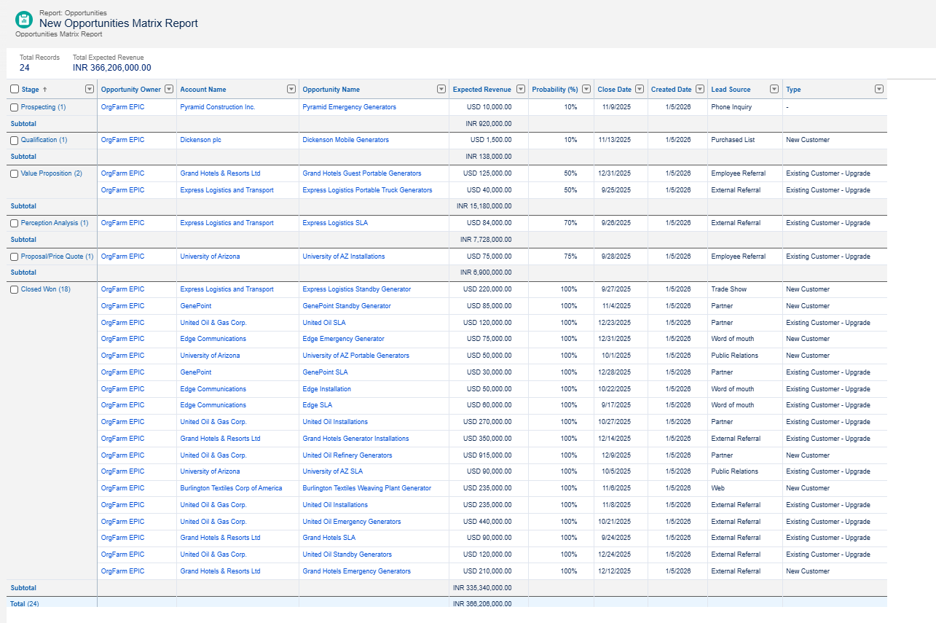

4. Create a joined report for Cases, Accounts, and Opportunity objects.
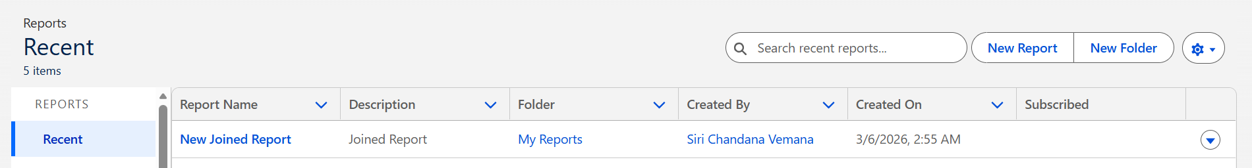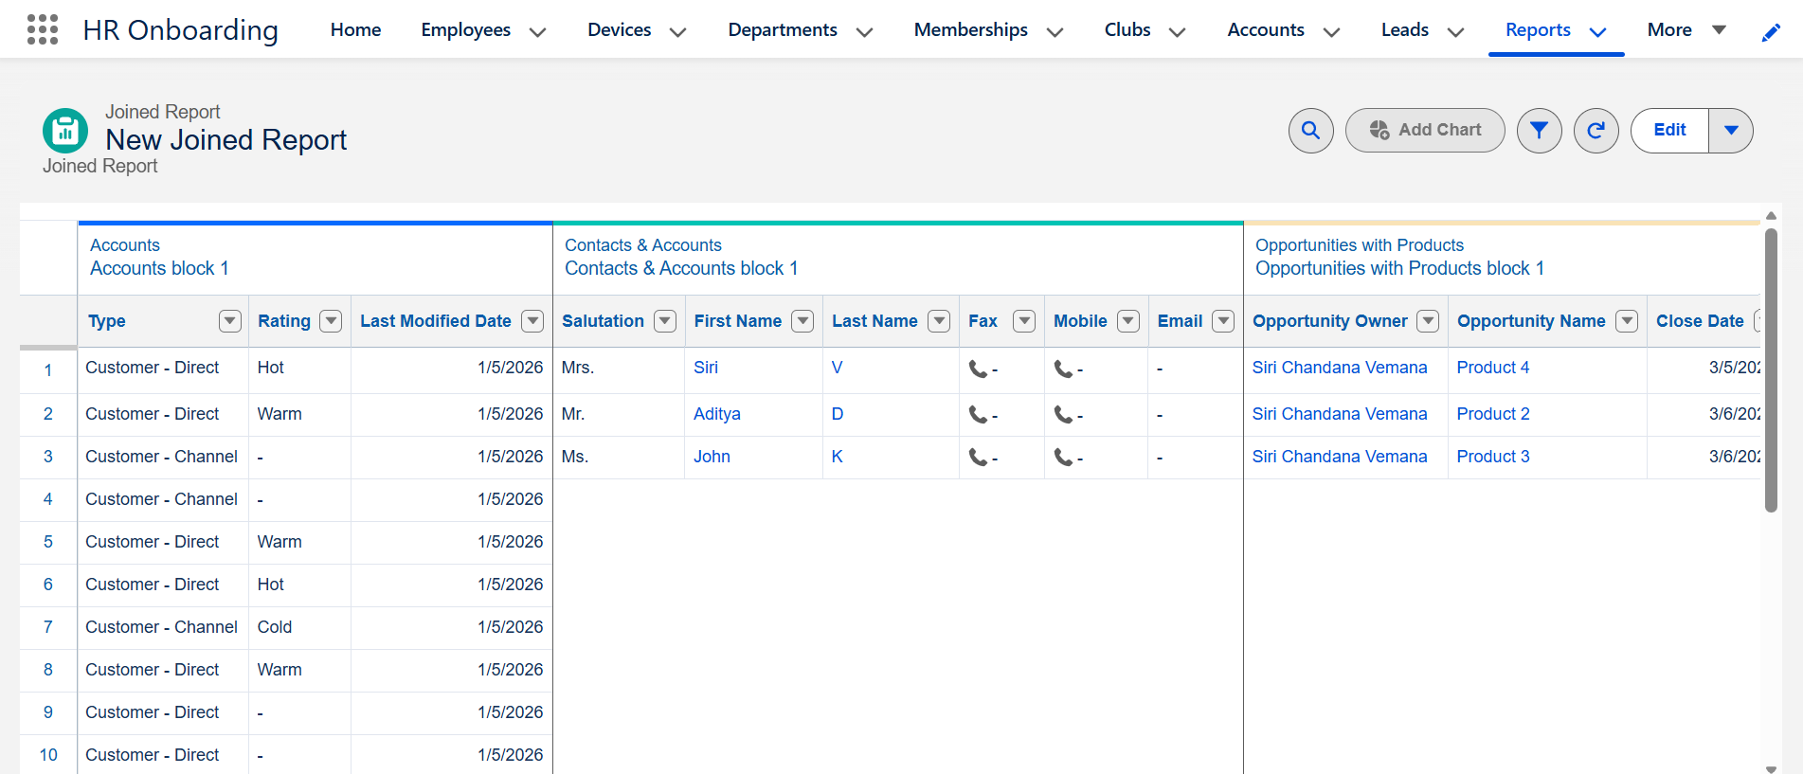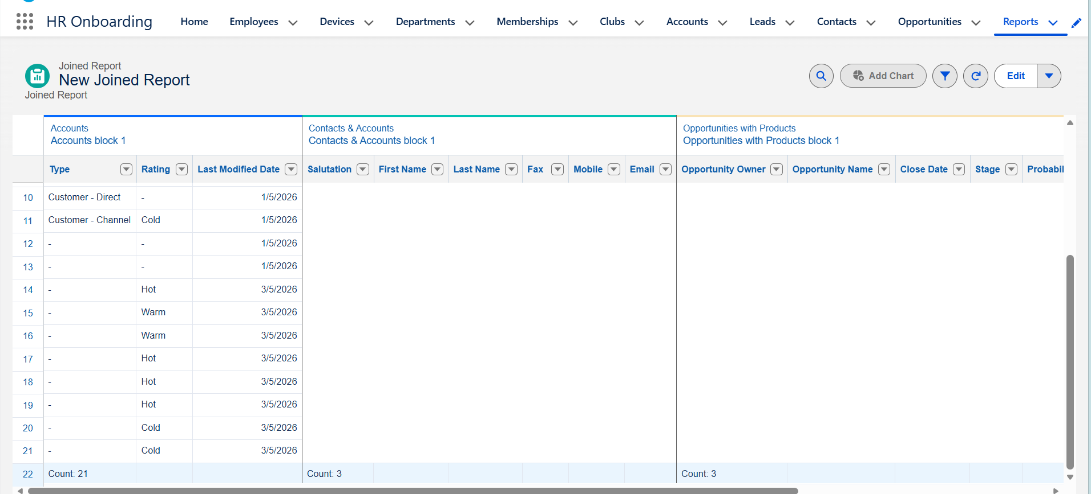

5. Create a custom report type named Opportunity with the primary object as Opportunity, the secondary object as Cases, and the tertiary object as Email. Then, create a tabular report for the custom report type.
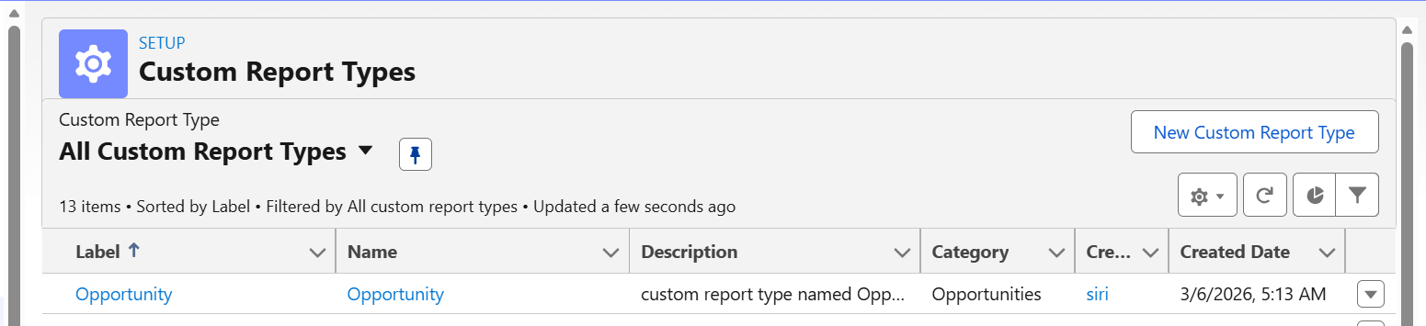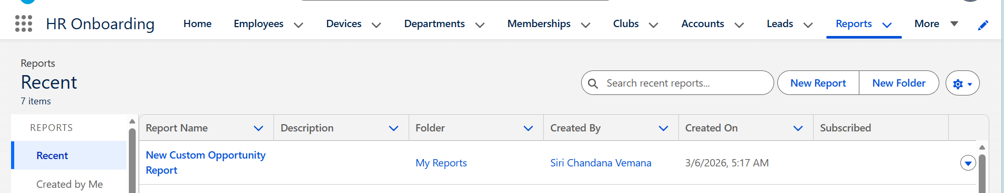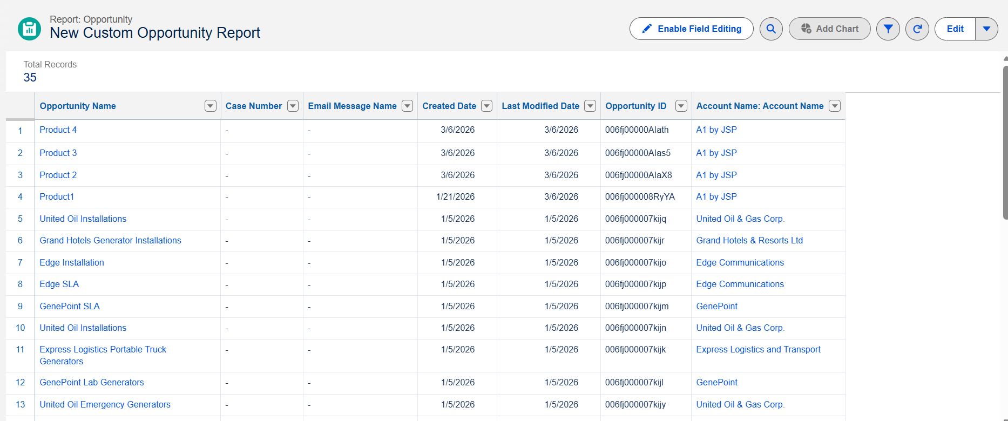

6. Create a dashboard for all the reports that you created.
